Maui Wardrobe

On Jesse:

jumpsuit, Free People http://www.freepeople.com

sundial watch, Pandeia http://pandeiastudio.com



button up, J. Crew https://www.jcrew.com/index.jsp

shoes, Converse http://www.converse.com

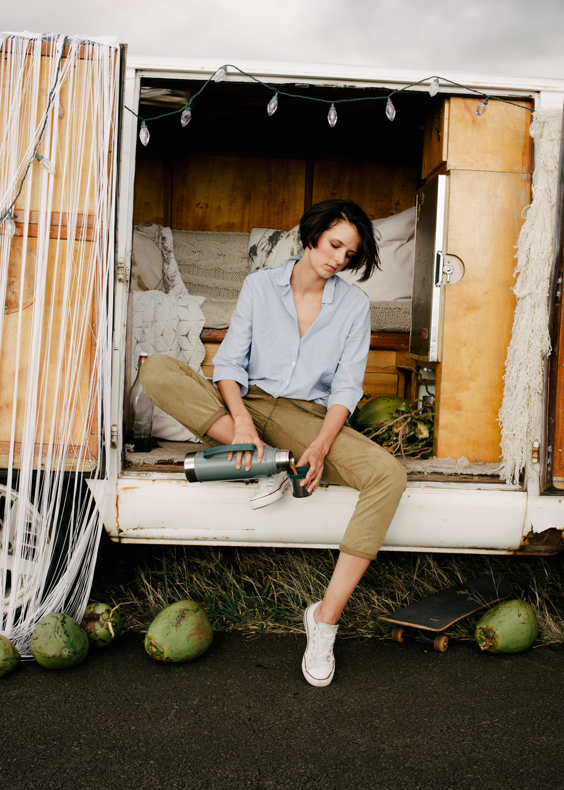

On Molly:

skirt, XTaren http://www.xtaren.com

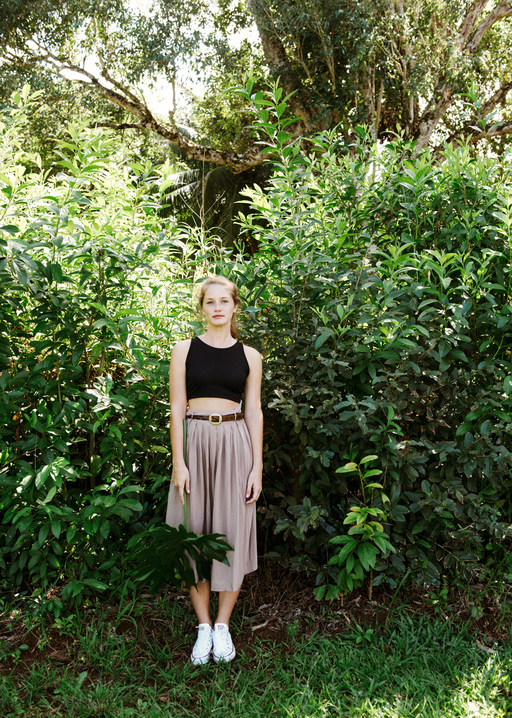

pants, J. Crew https://www.jcrew.com/index.jsp

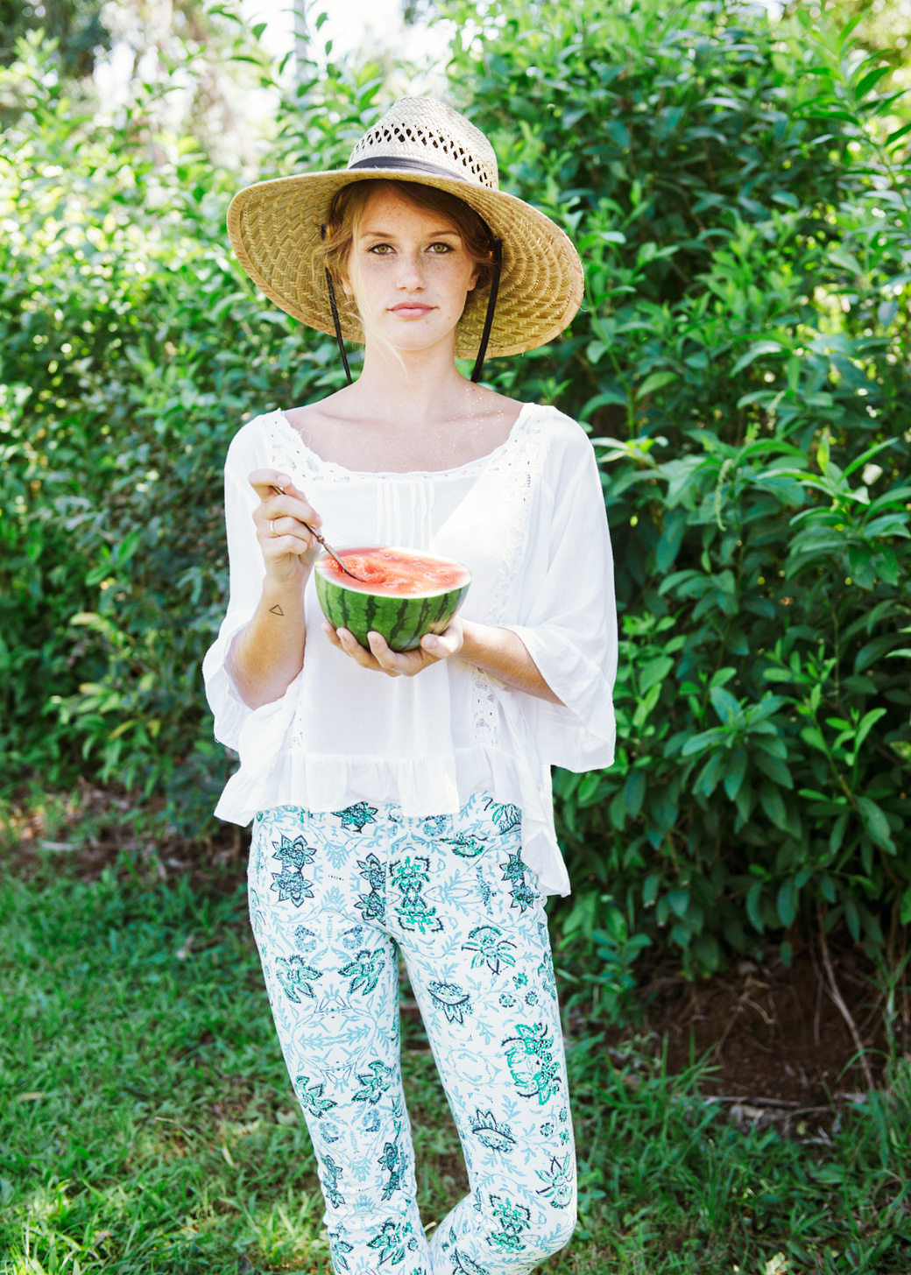

overalls, Free People, http://www.freepeople.com

black tank, Zara, http://www.zara.com/us/

